

**Course Title: Database Administrator Lab**

**Course Code: IT3142L**

**Project**

**Submitted by:**

* Student Name: Abdul Basit Shahzad
* Student Id : F2021105041
* Section: Y3

**Submitted to:**



Resource Person: Mr. Raybal Akhtar.

**Submission Date:**

* Jan 16, 2023

**Department of Informatics and Systems**

**Dr Hasan Murad School of Management (HSM**)

**University of Management & Technology**

**Hospital Management System**

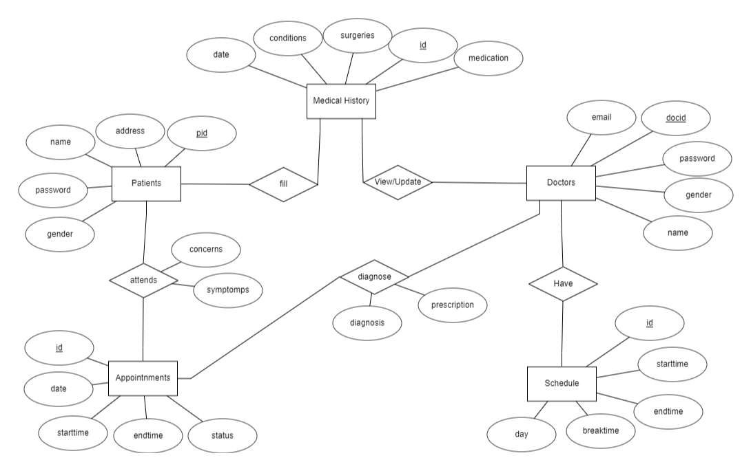**Entity Relationship Diagram**

**Relational Schemas with Integrity constraints**

1. Patient

|  |  |  |  |  |
| --- | --- | --- | --- | --- |
| **Pid** | Email | Password | Name | Address |

1. Doctor

|  |  |  |  |  |
| --- | --- | --- | --- | --- |
| **docid** | Name | Email | Gender | Password |

1. Medical History

|  |  |  |  |  |  |
| --- | --- | --- | --- | --- | --- |
| **Id** | Surgery | Medication | Condition | Date | Email |

1. Appointment

|  |  |  |  |  |
| --- | --- | --- | --- | --- |
| **appid** | Email | Password | Name | Address |

1. Schedules

|  |  |  |  |  |
| --- | --- | --- | --- | --- |
| **Sid** | Start Time | End Time | Holidays | Break Time |

1. Diagnose

|  |  |  |  |  |
| --- | --- | --- | --- | --- |
| **Appt,Doctor** | Diagnosis | Prescription | **Id** | **Docid** |

1. DocsHaveSchedules

|  |  |  |  |  |
| --- | --- | --- | --- | --- |
| **Sched,docter** | concerns | symptoms | **pid** | **appid** |

1. PatientsAttendAppointments

|  |  |  |  |
| --- | --- | --- | --- |
| **Patient,appt** | patient | **pid** | **id** |

1. **PatientsFillHistory**

|  |  |  |  |  |
| --- | --- | --- | --- | --- |
| **history** | Email | Password | Name | Address |

1. **DoctorViewsHistory**

|  |  |  |
| --- | --- | --- |
| **History,doctor** | **docid** | **id** |

CREATE TABLE Patient(

pid varchar(50) PRIMARY KEY,

email varchar(50) NOT NULL,

password varchar(30) NOT NULL,

name varchar(50) NOT NULL,

address varchar(60) NOT NULL,

gender VARCHAR(20) NOT NULL

);

INSERT INTO Patient (pid, email, password, name, address, gender)

VALUES

('P001', 'patient1@example.com', 'pass123', 'Ali Khan', '12 Lahore Street, Lahore', 'Male'),

('P002', 'patient2@example.com', 'pass456', 'Sana Ahmed', '34 Karachi Avenue, Karachi', 'Female'),

('P003', 'patient3@example.com', 'pass789', 'Bilal Ahmed', '56 Islamabad Road, Islamabad', 'Male'),

('P004', 'patient4@example.com', 'passabc', 'Ayesha Malik', '78 Rawalpindi Lane, Rawalpindi', 'Female'),

('P005', 'patient5@example.com', 'passdef', 'Imran Ali', '90 Faisalabad Lane, Faisalabad', 'Male'),

('P006', 'patient6@example.com', 'passefg', 'Fatima Khan', '112 Multan Street, Multan', 'Female'),

('P007', 'patient7@example.com', 'passhij', 'Usman Ali', '134 Peshawar Road, Peshawar', 'Male');

CREATE TABLE MedicalHistory(

id int PRIMARY KEY,

date DATE NOT NULL,

conditions VARCHAR(100) NOT NULL,

surgeries VARCHAR(100) NOT NULL,

medication VARCHAR(100) NOT NULL

);

INSERT INTO MedicalHistory (id, date, conditions, surgeries, medication)

VALUES

(1, '2022-05-15', 'Allergies', 'None', 'Antihistamines'),

(2, '2023-02-20', 'Diabetes', 'Appendectomy', 'Insulin'),

(3, '2021-11-10', 'Hypertension', 'Knee Surgery', 'Blood Pressure Medication'),

(4, '2024-03-05', 'Asthma', 'None', 'Inhaler'),

(5, '2022-08-12', 'Migraines', 'Gallbladder Removal', 'Painkillers'),

(6, '2023-07-30', 'Arthritis', 'Hip Replacement', 'Anti-Inflammatory'),

(7, '2021-12-18', 'Heart Disease', 'None', 'Beta Blockers');

CREATE TABLE Doctor(

docid varchar(50) PRIMARY KEY,

email varchar(50) NOT NULL,

gender varchar(20) NOT NULL,

password varchar(30) NOT NULL,

name varchar(50) NOT NULL

);

INSERT INTO Doctor (docid, email, gender, password, name)

VALUES

('D001', 'doctor1@example.com', 'Male', 'pass123', 'Dr. Ahmed Khan'),

('D002', 'doctor2@example.com', 'Female', 'pass456', 'Dr. Fatima Raza'),

('D003', 'doctor3@example.com', 'Male', 'pass789', 'Dr. Bilal Ahmed'),

('D004', 'doctor4@example.com', 'Female', 'passabc', 'Dr. Ayesha Malik'),

('D005', 'doctor5@example.com', 'Male', 'passdef', 'Dr. Imran Ali'),

('D006', 'doctor6@example.com', 'Female', 'passefg', 'Dr. Fatima Khan'),

('D007', 'doctor7@example.com', 'Male', 'passhij', 'Dr. Usman Ali');

CREATE TABLE Appointment(

appid int PRIMARY KEY,

date DATE NOT NULL,

starttime TIME NOT NULL,

endtime TIME NOT NULL,

status varchar(15) NOT NULL

);

INSERT INTO Appointment (appid, date, starttime, endtime, status)

VALUES

(1, '2022-12-10', '08:30:00', '09:30:00', 'Scheduled'),

(2, '2023-01-15', '10:00:00', '11:00:00', 'Completed'),

(3, '2023-02-20', '13:45:00', '14:45:00', 'Canceled'),

(4, '2023-03-25', '11:30:00', '12:30:00', 'Scheduled'),

(5, '2023-04-30', '15:15:00', '16:15:00', 'Completed'),

(6, '2023-05-05', '09:00:00', '10:00:00', 'Scheduled'),

(7, '2023-06-15', '14:00:00', '15:00:00', 'Completed');

CREATE TABLE PatientsAttendAppointments(

patient varchar(50) NOT NULL,

appt int NOT NULL,

concerns varchar(40) NOT NULL,

symptoms varchar(40) NOT NULL,

FOREIGN KEY (patient) REFERENCES Patient (pid) ON DELETE CASCADE,

FOREIGN KEY (appt) REFERENCES Appointment (appid) ON DELETE CASCADE,

PRIMARY KEY (patient, appt)

);

INSERT INTO PatientsAttendAppointments (patient, appt, concerns, symptoms)

VALUES

('P001', 1, 'Headache', 'Dizziness'),

('P002', 2, 'Cough', 'Fatigue'),

('P003', 3, 'Stomach Pain', 'Nausea'),

('P004', 4, 'Back Pain', 'Difficulty Breathing'),

('P005', 5, 'Joint Pain', 'Fever'),

('P006', 6, 'Sore Throat', 'Runny Nose'),

('P007', 7, 'Chest Pain', 'Shortness of Breath');

CREATE TABLE Schedule(

sid int PRIMARY KEY,

starttime TIME NOT NULL,

endtime TIME NOT NULL,

breaktime TIME NOT NULL,

day varchar(20) NOT NULL

);

INSERT INTO Schedule (sid, starttime, endtime, breaktime, day)

VALUES

(1, '08:00:00', '17:00:00', '12:00:00', 'Monday'),

(2, '09:00:00', '18:00:00', '13:00:00', 'Tuesday'),

(3, '10:00:00', '16:00:00', '14:00:00', 'Wednesday'),

(4, '11:00:00', '19:00:00', '15:00:00', 'Thursday'),

(5, '08:30:00', '16:30:00', '12:30:00', 'Friday'),

(6, '09:30:00', '17:30:00', '13:30:00', 'Saturday'),

(7, '10:30:00', '15:30:00', '14:30:00', 'Sunday');

CREATE TABLE PatientsFillHistory(

patient varchar(50) NOT NULL,

history int NOT NULL,

FOREIGN KEY (patient) REFERENCES Patient (pid) ON DELETE CASCADE,

FOREIGN KEY (history) REFERENCES MedicalHistory (id) ON DELETE CASCADE,

PRIMARY KEY (history)

);

INSERT INTO PatientsFillHistory (patient, history)

VALUES

('P001', 1),

('P002', 2),

('P003', 3),

('P004', 4),

('P005', 5),

('P006', 6),

('P007', 7);

CREATE TABLE Diagnose(

appt int NOT NULL,

doctor varchar(50) NOT NULL,

diagnosis varchar(40) NOT NULL,

prescription varchar(50) NOT NULL,

FOREIGN KEY (appt) REFERENCES Appointment (appid) ON DELETE CASCADE,

FOREIGN KEY (doctor) REFERENCES Doctor (docid) ON DELETE CASCADE,

PRIMARY KEY (appt, doctor)

);

INSERT INTO Diagnose (appt, doctor, diagnosis, prescription)

VALUES

(1, 'D001', 'Migraine', 'Painkillers'),

(2, 'D002', 'Respiratory Infection', 'Antibiotics'),

(3, 'D003', 'Gastritis', 'Antacids'),

(4, 'D004', 'Herniated Disc', 'Pain Medication'),

(5, 'D005', 'Rheumatoid Arthritis', 'Anti-Inflammatory Drugs'),

(6, 'D006', 'Pharyngitis', 'Throat Lozenges'),

(7, 'D007', 'Coronary Artery Disease', 'Blood Thinners');

CREATE TABLE DocsHaveSchedules(

sched int NOT NULL,

doctor varchar(50) NOT NULL,

FOREIGN KEY (sched) REFERENCES Schedule (sid) ON DELETE CASCADE,

FOREIGN KEY (doctor) REFERENCES Doctor (docid) ON DELETE CASCADE,

PRIMARY KEY (sched, doctor)

);

INSERT INTO DocsHaveSchedules (sched, doctor)

VALUES

(1, 'D001'),

(2, 'D002'),

(3, 'D003'),

(4, 'D004'),

(5, 'D005'),

(6, 'D006'),

(7, 'D007');

CREATE TABLE DoctorViewsHistory(

history int NOT NULL,

doctor varchar(50) NOT NULL,

FOREIGN KEY (doctor) REFERENCES Doctor (docid) ON DELETE CASCADE,

FOREIGN KEY (history) REFERENCES MedicalHistory (id) ON DELETE CASCADE,

PRIMARY KEY (history, doctor)

);

INSERT INTO DoctorViewsHistory (history, doctor)

VALUES

(1, 'D001'),

(2, 'D002'),

(3, 'D003'),

(4, 'D004'),

(5, 'D005'),

(6, 'D006'),

(7, 'D007');

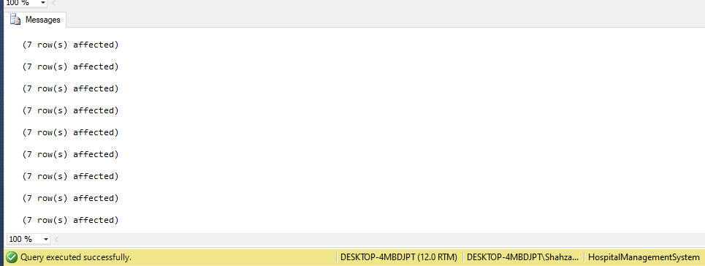

**Stored Procedure of every DML operations**

**Stored Procedure for SELECT:** This stored procedure retrieves patient information along with their medical history.

CREATE PROCEDURE GetPatientMedicalHistory

@PatientID varchar(50)

AS

BEGIN

SELECT P.*, MH.*

FROM Patient P

JOIN PatientsFillHistory PFH ON P.pid = PFH.patient

JOIN MedicalHistory MH ON PFH.history = MH.id

WHERE P.pid = @PatientID;

END;

EXEC GetPatientMedicalHistory @PatientID = 'P001'



**Stored Procedure for INSERT:** This stored procedure is for Inserting the new appointment.

CREATE PROCEDURE InsertAppointment

@AppointmentID INT,

@Date DATE,

@StartTime TIME,

@EndTime TIME,

@Status VARCHAR(15)

AS

BEGIN

INSERT INTO Appointment (appid,date, starttime, endtime, status)

VALUES (@AppointmentID,@Date, @StartTime, @EndTime, @Status);

END;

EXEC InsertAppointment

@AppointmentID = 365,

@Date = '2022-06-15',

@StartTime = '14:00:00',

@EndTime = '15:00:00',

@Status = 'Scheduled';

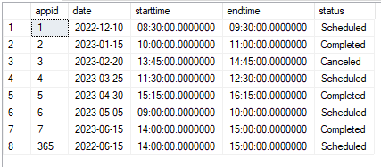

**Stored Procedure for UPDATE:** This stored procedure updates the date and time of an existing appointment in the **Appointment** table.

CREATE PROCEDURE RescheduleAppointment

@AppointmentID INT,

@NewDate DATE,

@NewStartTime TIME,

@NewEndTime TIME,

@NewStatus Varchar(50)

AS

BEGIN

UPDATE Appointment

SET date=@NewDate,

starttime=@NewStartTime,

endtime =@NewEndTime,

status=@NewStatus

WHERE appid =@AppointmentID;

END;

EXEC RescheduleAppointment

@AppointmentID = 365,

@NewDate = '2024-01-13',

@NewStartTime = '21:00:00',

@NewEndTime = '11:00:00',

@NewStatus='Rescheduled';

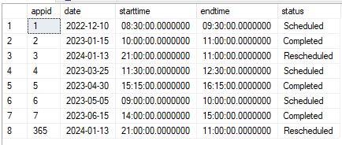



**Stored Procedure for DELETE:** This stored procedure cancels a scheduled appointment and removes related records.

CREATE PROCEDURE CancelAppointment

@AppointmentID int

AS

BEGIN

DELETE FROM PatientsAttendAppointments WHERE appt = @AppointmentID;

DELETE FROM Diagnose WHERE appt = @AppointmentID;

DELETE FROM Appointment WHERE appid = @AppointmentID;

END;

EXEC CancelAppointment

@AppointmentID=3

